**Introduction to Data Scientist 11372 (UG)**

**Final Assessment Part D – Documentation and Reporting**

Tuan Anh (Vincent) Nguyen – u3196825

Table of Contents

Task 2 Exploratory Data Analysis 2

Q1: 2

Q2: 3

Q3: 4

Q4: 5

Q5: 5

Q6: 6

Q7: 7

Q8: 9

Q9: 10

Q10: 11

Task 3: Data-Driven Modelling: 12

Q1: 12

Q2: 12

Q3: 13

Q4: 14

Q5: 16

# Task 2 Exploratory Data Analysis

## Q1:

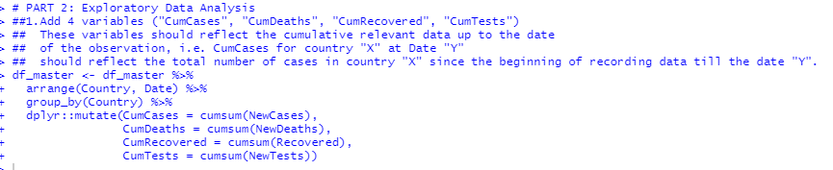

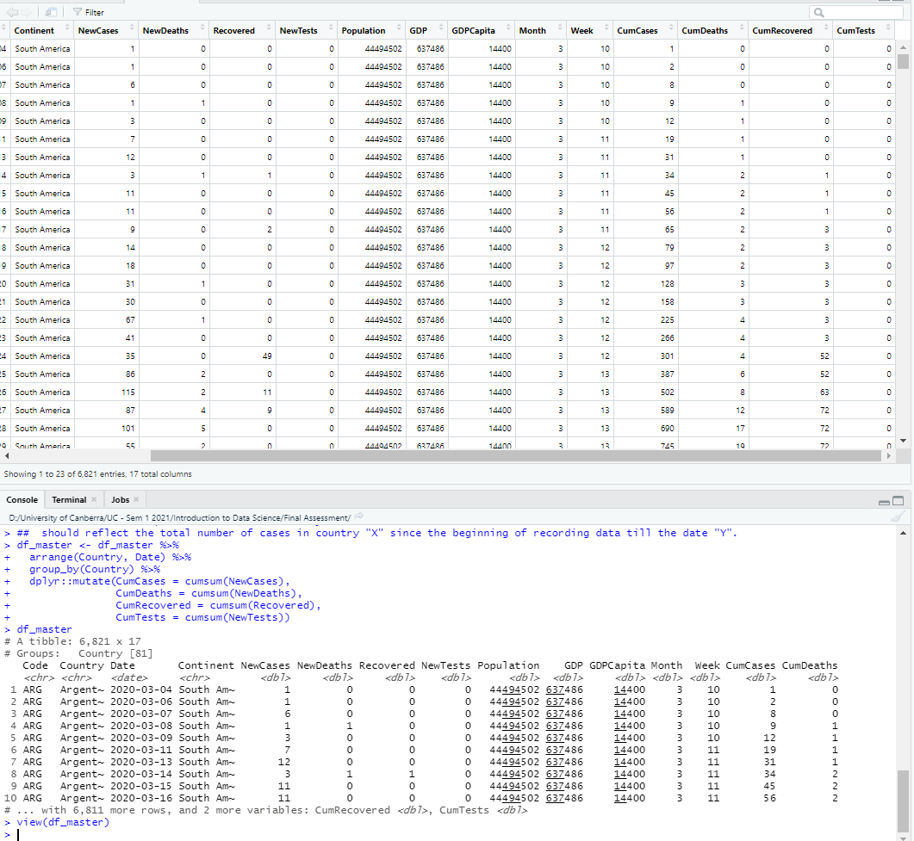

## Q2:

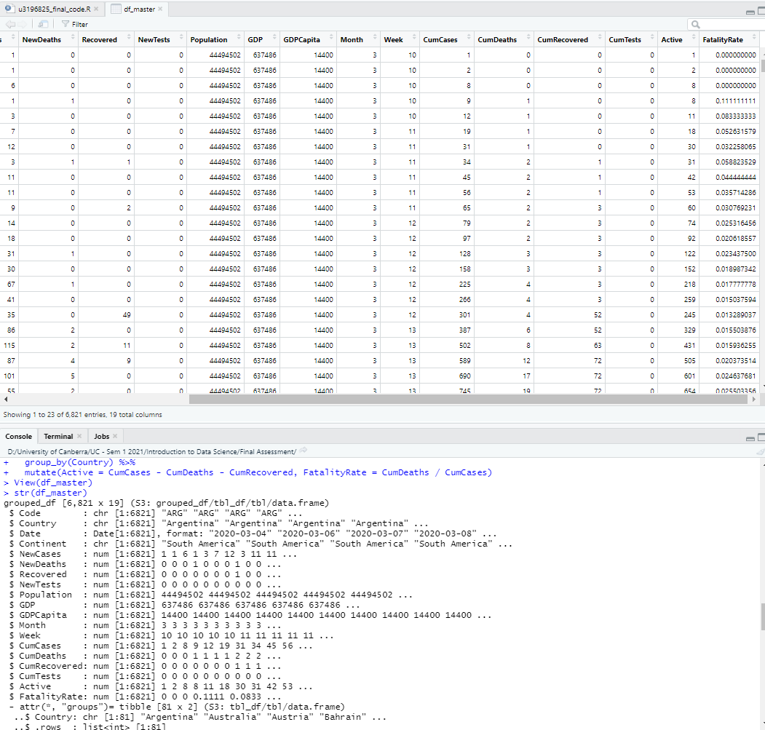

NOTE: however, at this state, I discovered the there are number of NaN(s) in Fatality Rate (due to divide by 0 in some rows). So, I change them into 0 for easier calculation.



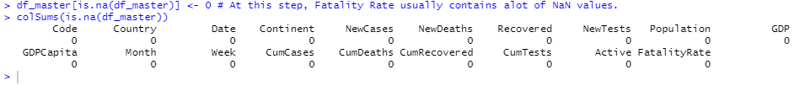

## Q3:

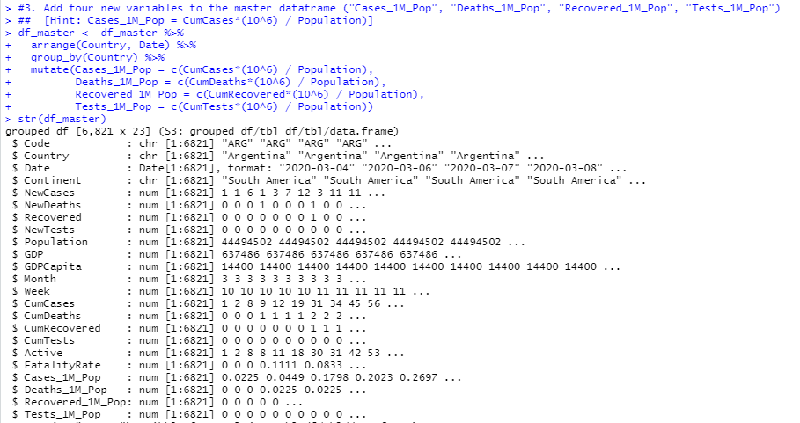

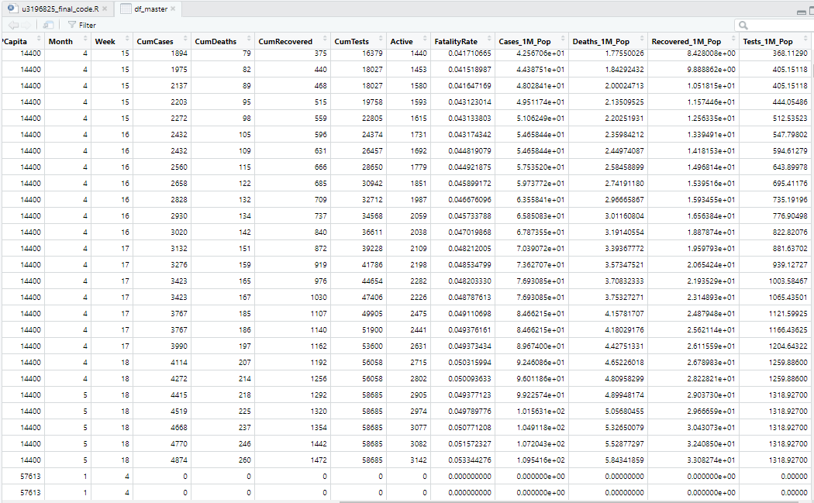

## Q4:

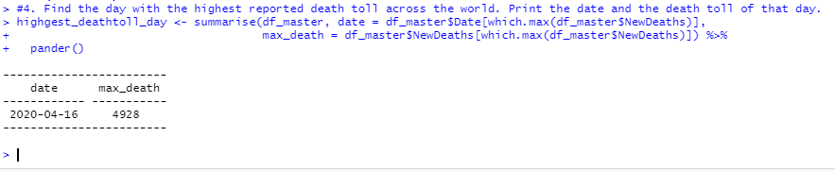

## Q5:

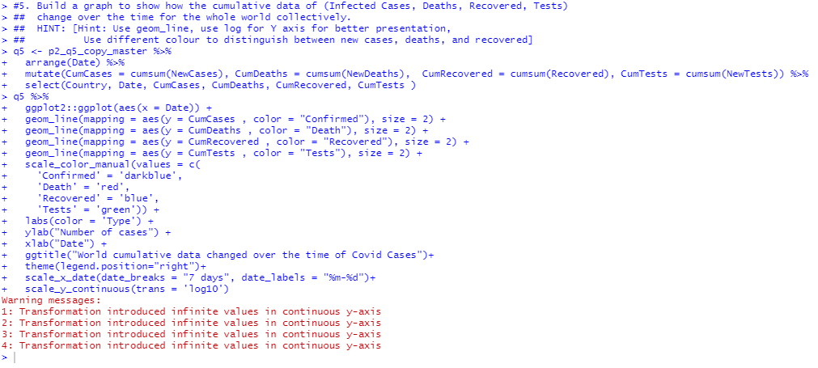

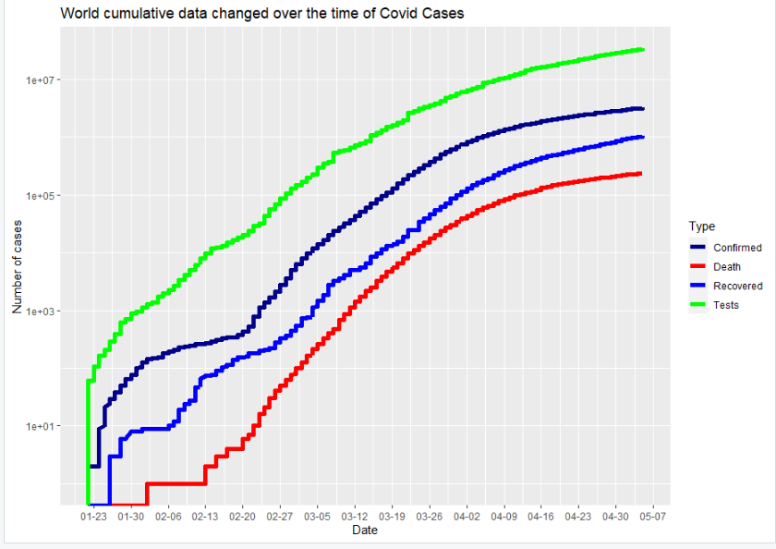

## Q6:

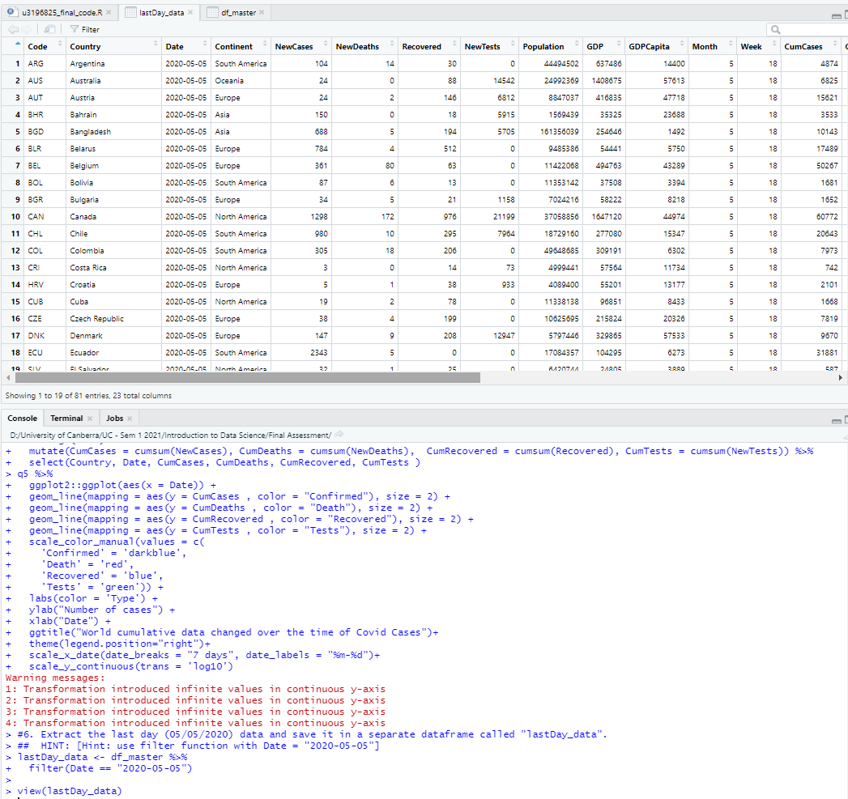

## Q7:

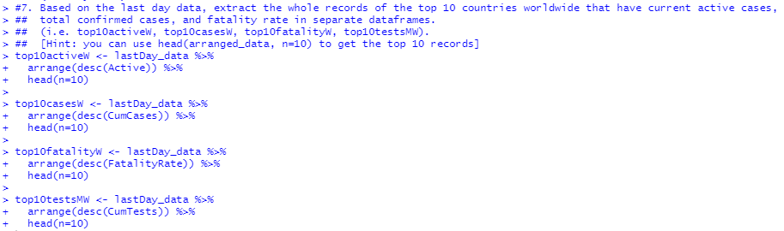

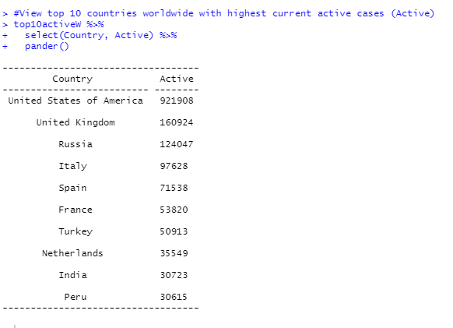

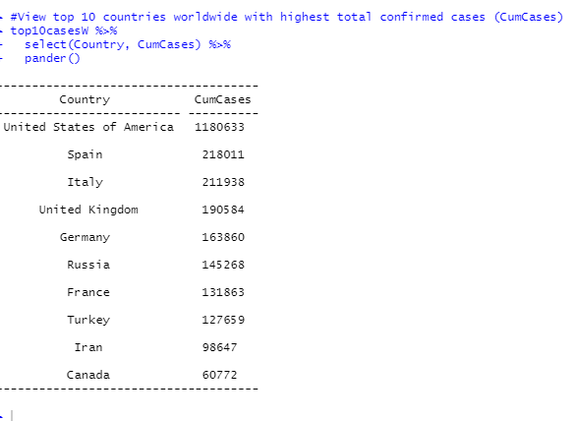

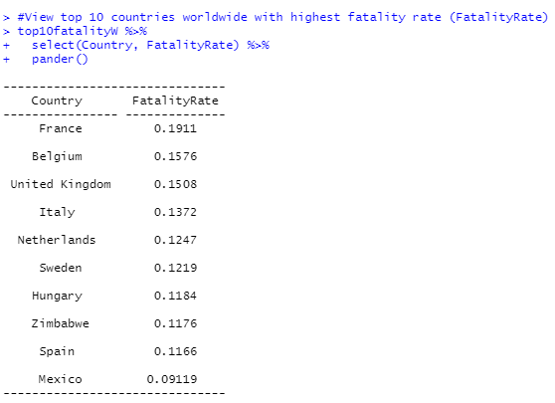

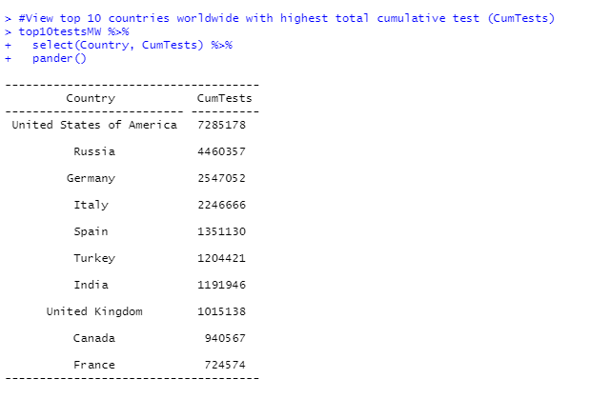

## Q8:

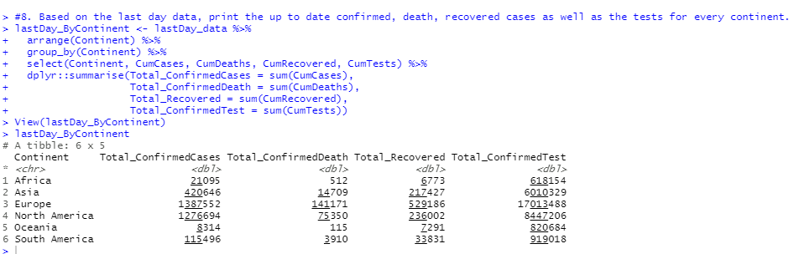

## Q9:

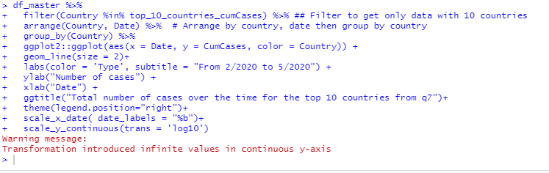

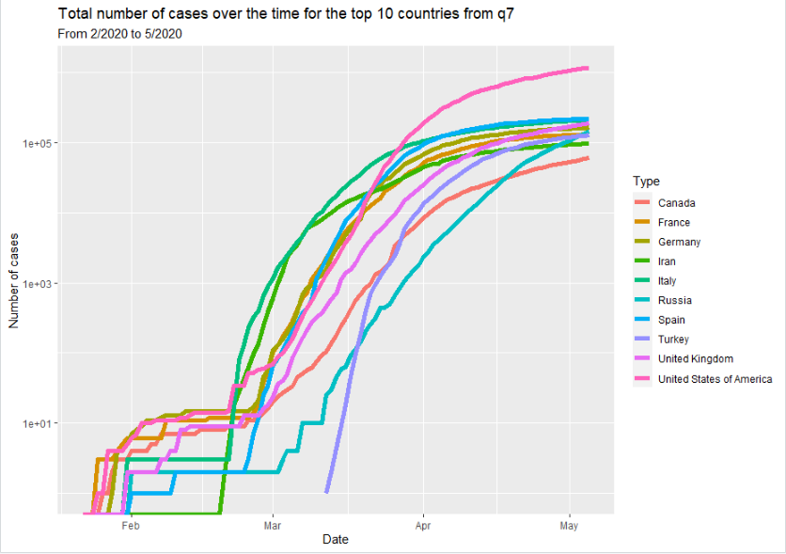

## Q10:

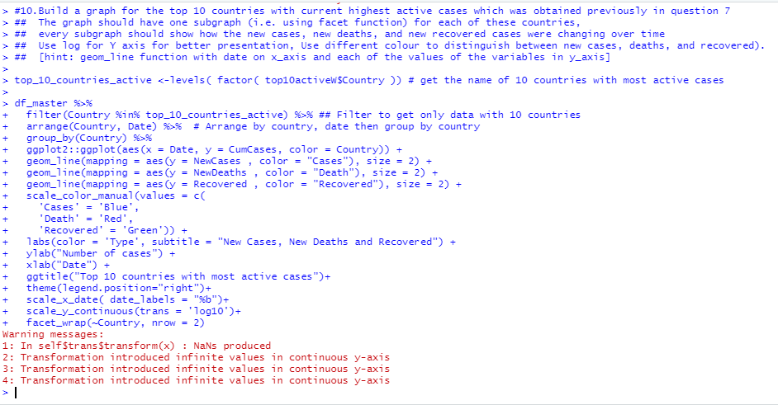

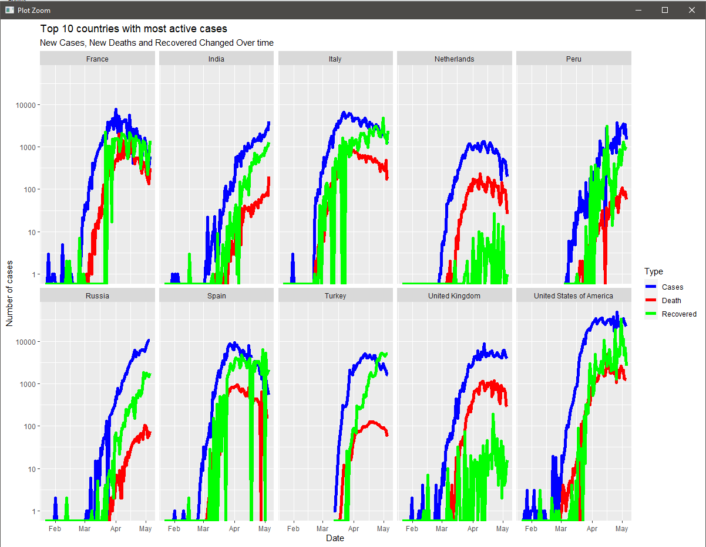

# Task 3: Data-Driven Modelling:

## Q1:

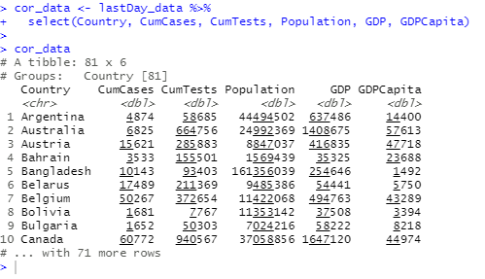

## Q2:

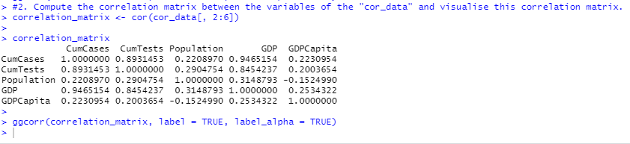

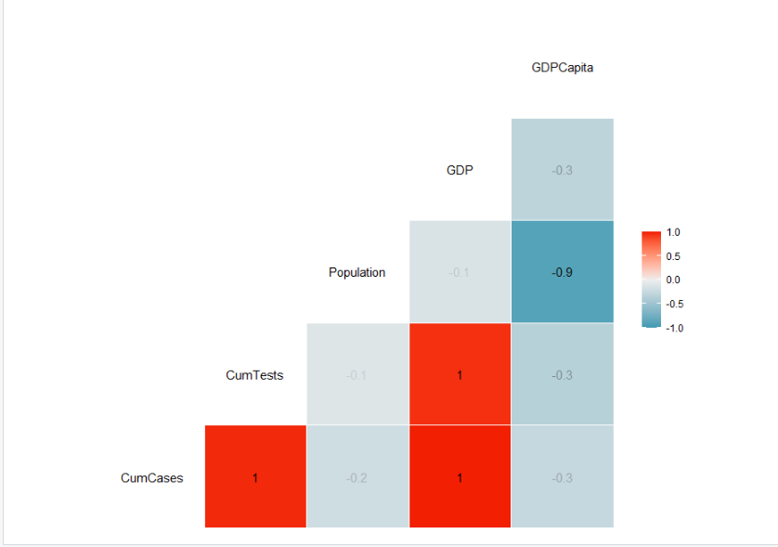

## Q3:

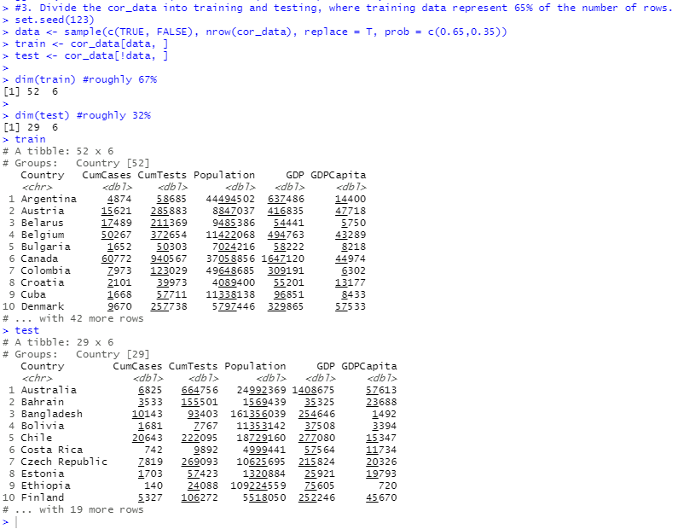

## Q4:

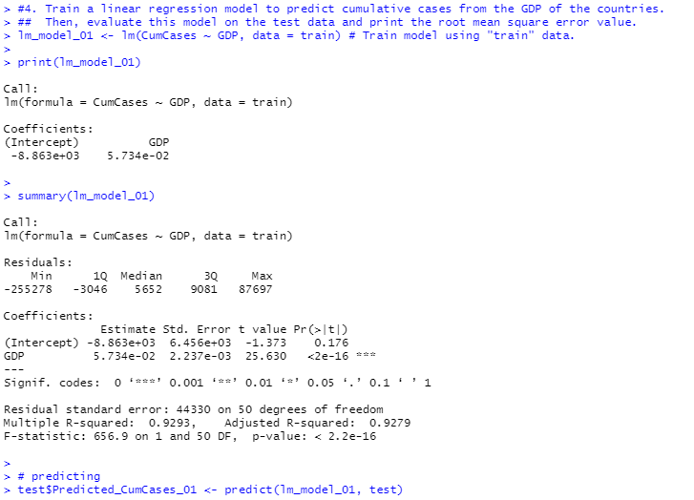

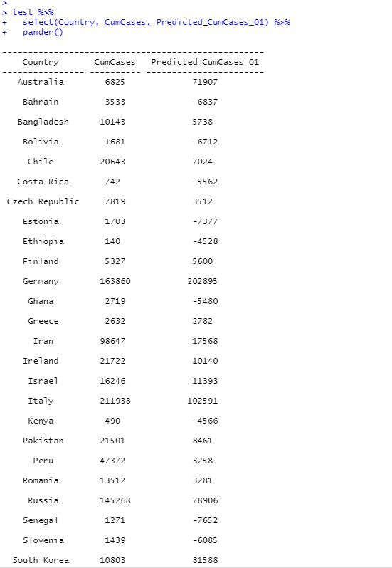

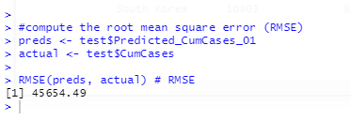

## Q5:

